Chapter 16, Solution 87.

Develop the state equations for the problem you designed in Prob. 16.13.

Although there is no correct way to work this problem, this is an example based on the same kind of problem asked in the third edition.

Problem

Develop the state equations for Problem 16.13.

Chapter 16, Problem 13.

Find v_{x} in the circuit shown in Fig. 16.36 given v_{s} = 4u(t) V.

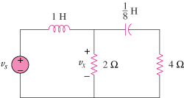

Figure 16.36

Solution
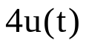
4Ω
+
v_{x}
−
1H
1/8 F

+
−
2Ω

First select the inductor current i_{L} and the capacitor voltage v_{C} to be the state variables.

Applying KCL we get:

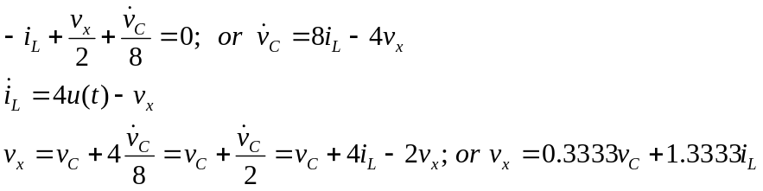

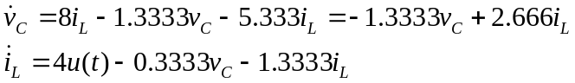

Now we can write the state equations.

